Jade Belmont
Student in master’s degree at les Roches Marbella
 | EXPERIENCES
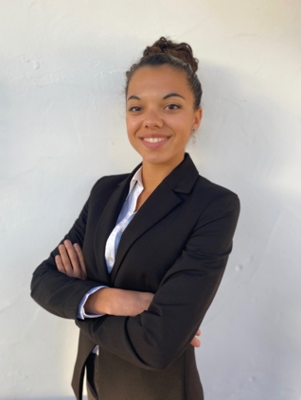  EDUCATION —  2020-2022 Les Roches Marbella  Master in international management  2017-2020 Vatel Paris  Bachelor in international management  2014-2017 Lycée Alcided’Obigny, Bouaye France  BACCALAUREAT economic and social  Driver’s license 2017  PROFIL—  I am currently in master's degree in Les Roches  I am the big sister of 3 siblings  I love children and am really used to children and babies  I have taken care of my brothers since I was 8  I have a good experience because I have been babysitting since I was 13 years old I like to be with children | 07-09 /  2020 Nantes family I was taking care of 2 girls of 9 months and 5 years old every morning and after school  11 / 2018-  05/2019 Family Charleston US I was taking care of a 2 years old baby in the evening after my internship in a hotel  06-05 /  2018 Nantes family 3 children aged 2,5, 8 years old. Pick them up after school I was with them until their parents were home (9 p.m.)  12 / 17-04 /  18 Nantes family babysitting of 1 child of 3 years 1 baby of 9 months for 1 year every weekend  2014/2015  2016 Host family Castro Valley, United States  3 Summers fille au pair
 | LANGUES
French mother tongue
English bilingual
German notion

INTERESTS

Synchronized swimming, surfing, cooking, painting, language, foreign cultures
Countries visited: United States, Germany, Italy, Spain, Portugal, England, Greece

